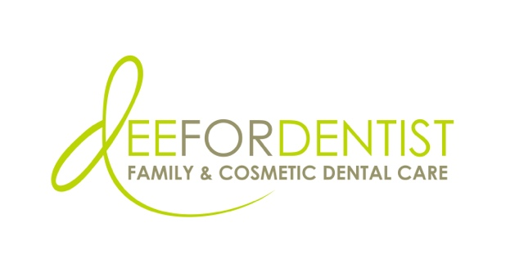

For Immediate Release

Dee for Dentist Grows Team with Addition of Drs. Steve Lam and Ana Hu

UNLV alumnae bring range of expertise in comprehensive and preventative dental care services

May 9, 2024 – Las Vegas – Dee for Dentist, a state-of-the-art dental practice embracing groundbreaking technological innovations and techniques to treat and manage oral care, announces the addition of two new doctors, Dr. Steve Lam and Dr. Ana Hu, both alumni of the University of Nevada, Las Vegas School of Dental Medicine – the alma mater of Dr. Dee Dee Meevasin, owner and primary clinician at Dee for Dentist.

“We are excited to welcome Dr. Lam and Dr. Hu to our team,” said Dr. Meevasin. “Their wealth of expertise not only enriches our practice, but their commitment to forging genuine connections aligns perfectly with our patient-centered approach, ensuring unparalleled care for our patients.”
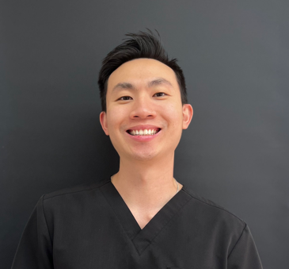
Dr. Lam
A Las Vegas native, Dr. Lam attended the University of Nevada, Las Vegas School of Dental Medicine where he earned his Doctor of Dental Medicine. Specializing in conservative dentistry, he focuses on relieving patients from dental pain by addressing various oral issues such as decay removal, repairing fractured teeth and fillings, performing crowns and implants, conducting orthodontic procedures, evaluating airways, and providing thorough cleanings.
Dr. Lam
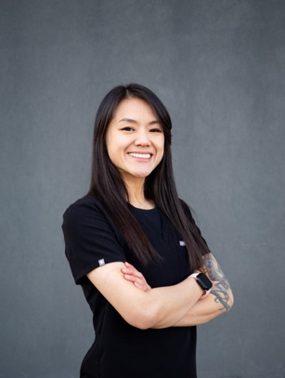
Dr. Hu
Originally from Taiwan, Dr. Hu attended San Francisco State University and the University of Nevada, Las Vegas School of Dental Medicine. Providing a meticulous blend of patient care, consultation, and treatment, Dr. Hu's focus remains on her patients' well-being, embodying a philosophy centered on empathy and informed decision-making.

Active members in the community, Dr. Lam and Dr. Hu are passionate about promoting oral hygiene education while embracing the latest dental advancements to enhance patient experience.
Dr. Hu

Dr. Lam is assisting patients at the Silverado practice located at 8772 S Maryland Pkwy, Las Vegas, NV 89123, open Monday through Saturday from 9 a.m. to 5:30 p.m. Dr. Hu is treating patients at the Medical District location at 2421 West Charleston Blvd., Las Vegas, NV 89102, open Monday through Thursday from 8 a.m. to 5 p.m.

Founded in 2011, Dee for Dentist is a family practice providing the latest in digital dentistry along with traditional dental services as a means to promote the long-term oral health of every patient. For more information, visit www.deefordentist.com.

About Dee for Dentist:
An industry leader, Dee for Dentist is a local family practice providing state-of-the-art digital dentistry to the Southern Nevada community. Dr. Dee Dee Meevasin, a Las Vegas native and a graduate of the UNLV School of Dental Medicine with over two decades of industry experience, started the practice in 2011 and embraces technology along with traditional dental services as a means to promote the long-term oral health of every patient.

As the first in Las Vegas to use many of the groundbreaking innovations and techniques developed for the dental industry to treat and manage oral care, the practice offers the most advanced treatments available, including: laser dentistry, myofunctional therapy appliances for children, digital nitrous, oral sleep appliances, oral cancer detection, 3D printing, CEREC same-day crown restorations, and 3D screening for advanced airway analysis to address sleep apnea and other oral health related issues.

Dee for Dentist is a clinical partner for TeamSmile, a national organization that partners dental practices with professional athletic organizations to provide life-changing dental care to underserved children in local communities.

Dee for Dentist’s Silverado Ranch practice, located at 8772 S Maryland Pkwy, Las Vegas, NV 89123, is open Monday through Saturday from 9 a.m. to 5:30 p.m. and their Charleston practice, located at 2421 West Charleston Blvd., Las Vegas, NV 89102, is open Monday through Thursday from 8 a.m. to 5 p.m. For more information, visit www.deefordentist.com or follow @deefordentist on Facebook and Instagram. Appointments can be requested online or made by calling (702) 586-7800.

Media Contact:
Mallory Zito
GYC Vegas
(702) 560-6590
mallory@gycvegas.com

