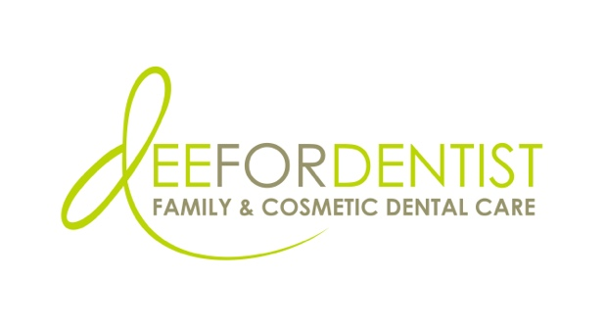

---POST-EVENT MEDIA ADVISORY---PHOTOS/B-ROLL---

Local Dental Practice, Dee for Dentist, Announces Winners of
Tooth Fairy Castle Design & Story Contest with Clark County School District

Cash prizes, dental goodies, and assemblies awarded to individual students and
top participating class and school

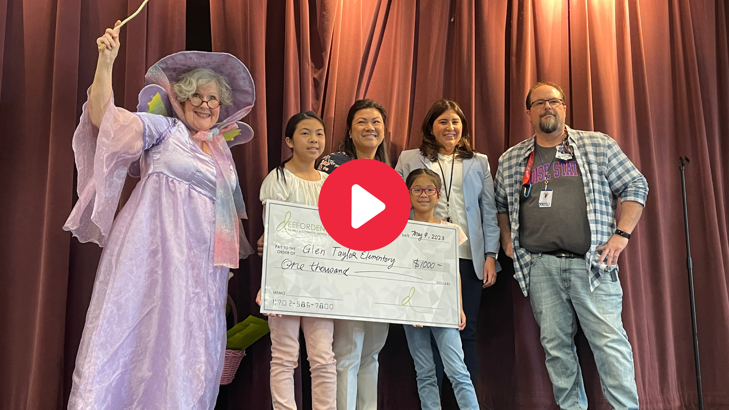

Click the image above for video of Dr. Dee Dee Meevasin presenting cash prizes to the top participating school and class.
LAS VEGAS – May 10, 2023 – Earlier this year, Dee for Dentist, a state-of-the-art dental practice embracing groundbreaking technological innovations and techniques to treat and manage oral care, partnered with Clark County School District (CCSD) to host a district-wide design and story contest for elementary students.

The contest, which received over 2,500 entries, invited students grades K-5 to submit a one-page drawing of what they think the Tooth Fairy’s castle looks like, accompanied by a brief description.

After careful review, Dr. Dee Dee Meevasin, owner and primary clinician at Dee for Dentist, is proud to announce the winning school, class, and students:
        - Top school: Glen Taylor Elementary at 647 entries
          - Received a $1,000 cash donation plus an assembly with Dr. Dee Dee Meevasin and the Tooth Fairy, where she talked about the importance of good oral hygiene, what it's like to be a dentist, and how you can become one.
        - Top class: Decker Elementary – Ms. Baird’s fifth grade class at 40 entries
          - Received a $500 cash donation plus a special classroom visit from the Tooth Fairy and Dee for Dentist's owner and primary clinician, Dr. Dee Dee Meevasin, with dental goodies.
        - Top 3 students:
          - 1st place: Charmella W., Helen M. Smith Elementary
          - 2nd place: Parnian S., Lewis E. Rowe Elementary
          - 3rd place: Cole M., Glen Taylor Elementary

Each winning student received cash prizes, a congratulatory letter and certificate from Dr. Dee Dee Meevasin, a complementary Healthy Start assessment, and have their artwork on display at Dee for Dentist’s Silverado Ranch location. All entries were judged on creativity, uniqueness, and description.

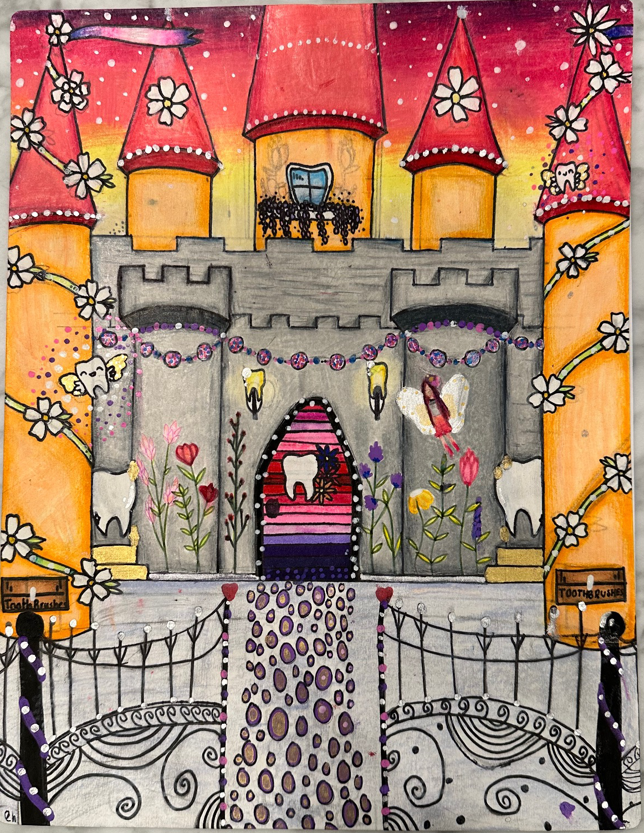

First place design by Charmella W. at Helen M. Smith Elementary
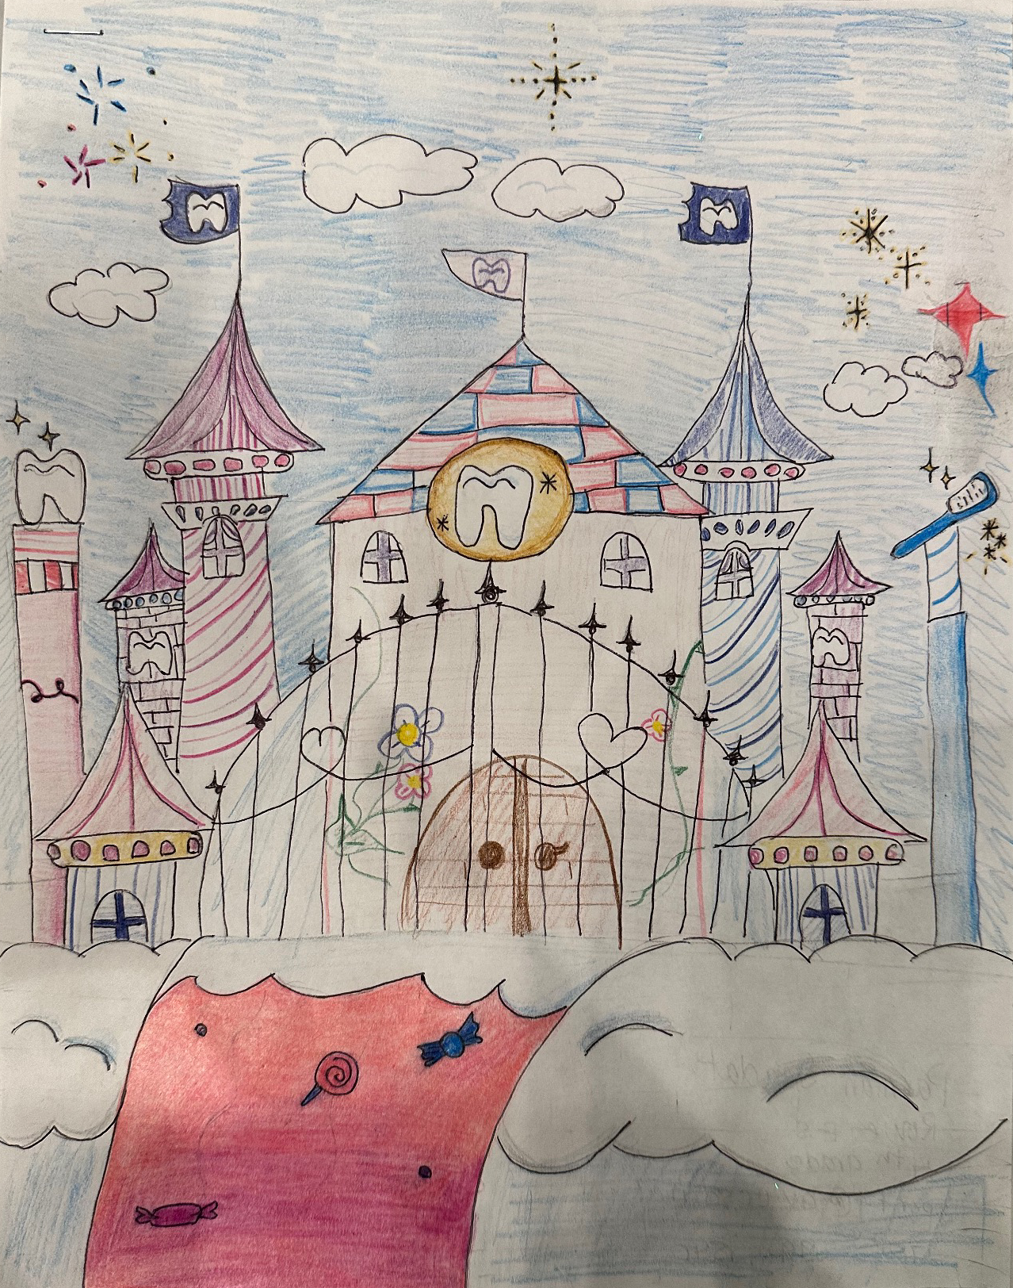

Second place design by Parnian S. at Lewis E. Rowe Elementary
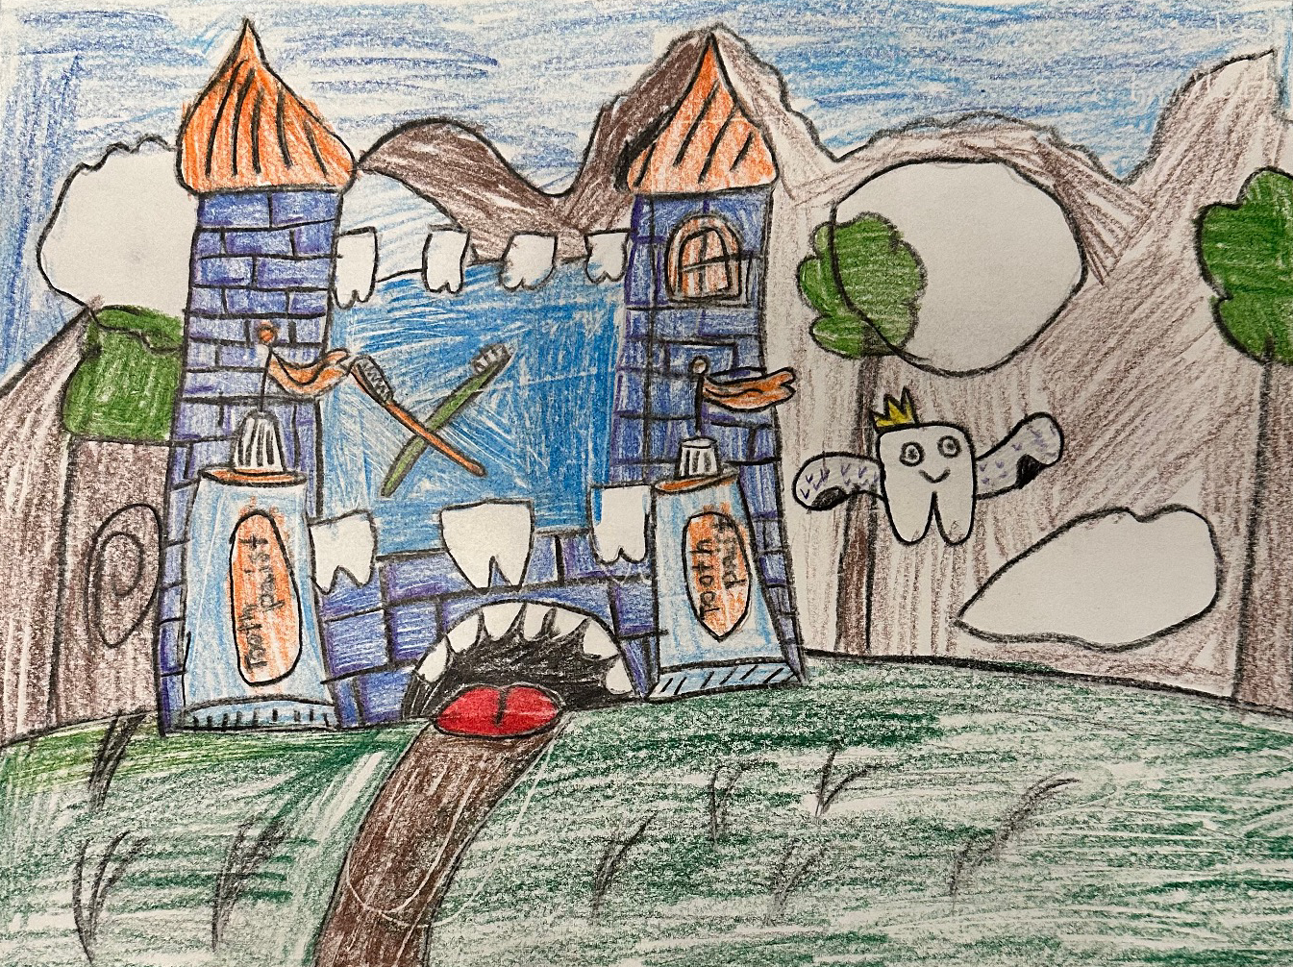

Third place design by Cole M. at Glen Taylor Elementary

About Dee for Dentist:
An industry leader, Dee for Dentist is a local family practice providing state-of-the-art digital dentistry to the Southern Nevada community. Dr. Dee Dee Meevasin, a Las Vegas native and a graduate of the UNLV School of Dental Medicine with over two decades of industry experience, started the practice in 2011 and embraces technology along with traditional dental services as a means to promote the long-term oral health of every patient.

As the first in Las Vegas to use many of the groundbreaking innovations and techniques developed for the dental industry to treat and manage oral care, the practice offers the most advanced treatments available, including: laser dentistry, myofunctional therapy appliances for children, digital nitrous, oral sleep appliances, oral cancer detection, 3D printing, CEREC same-day crown restorations, and 3D screening for advanced airway analysis to address sleep apnea and other oral health related issues.

Dee for Dentist is a clinical partner for TeamSmile, a national organization that partners dental practices with professional athletic organizations to provide life-changing dental care to underserved children in local communities.

Dee for Dentist’s Silverado Ranch practice, located at 8772 S Maryland Pkwy, Las Vegas, NV 89123, is open Monday through Saturday from 9 a.m. to 5:30 p.m. and their Charleston practice, located at 2421 West Charleston Blvd., Las Vegas, NV 89102, is open Monday through Thursday from 8 a.m. to 5 p.m. For more information, visit www.deefordentist.com or follow @deefordentist on Facebook and Instagram. Appointments can be requested online or made by calling (702) 586-7800.

###
Media Contact:
Mallory Zito/Briana Philippi
GYC Vegas
(702) 560-6590
mallory@gycvegas.com
briana@gycvegas.com

