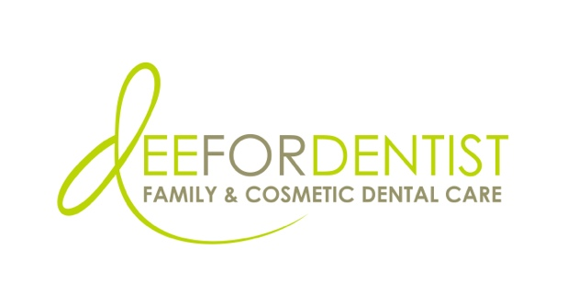

For Immediate Release

Dee for Dentist Becomes First Dental Practice in Western U.S. to Utilize
First-Ever Medical Grade 3D Printing System for Dentistry

Highly automated advanced technology provides expanded treatment with same-day, in-house production of temporary teeth, dentures, night guards, and more

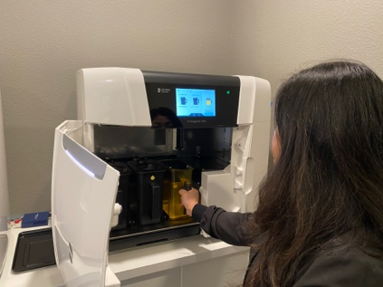
August 2, 2022 – Las Vegas – Dee for Dentist, a state-of-the-art dental practice embracing groundbreaking technological innovations and techniques to treat and manage oral care, is now the first dental practice in the Western U.S. to utilize the first-ever medical grade 3D printer for dentistry – the Primeprint 3D Printing System by Dentsply Sirona. The highly automated advanced technology provides expanded treatment with same-day, in-house production as the printer can create temporary teeth, dentures, night guards, digital wax-ups, custom trays for impressions, surgical guides, and print dental models.
Dee for Dentist is the first dental practice in the Western U.S. to utilize the first-ever medical grade 3D printer for dentistry.

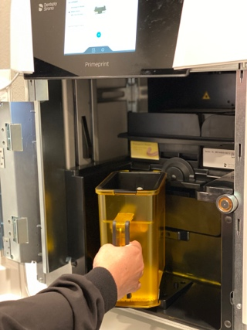
The FDA approved printer designed specifically for the dental industry is a highly automated, end-to-end, medical grade 3D printing system that helps to reduce handling times and enable a high level of productivity. Dee for Dentist acquired the technology in July.

“I founded Dee for Dentist with the goal of providing Southern Nevada access to the latest technology. To have a chairside 3D printer that can create teeth and dentures, among other things, in one day is an amazing service we are now able to offer. It is like science fiction has come to life, allowing us to take our level of patient care to the next level,” said Dr. Dee Dee Meevasin, owner and primary clinician at Dee for Dentist. “We can’t wait for our patients to witness the future of dental medicine right now – in the present.”
Dee for Dentist’s Primeprint 3D Printing System by Dentsply Sirona provides expanded treatment with same-day, in-house production.

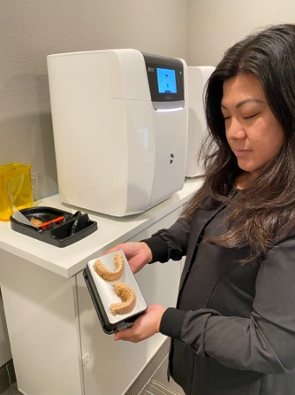
Prior to the release of the Primeprint system, chairside 3D printing was messy, inefficient, and unpredictable. Traditionally, a dental practice takes a patient scan, sends it to an outside lab to convert into a file that they can then print, or the lab manufactures the product and ships it back. With this new technology, the entire process is automated in-house, significantly reducing human error by eliminating the need for employees to wear gloves, rinse equipment and manually process the materials. The all-digital system also improves accuracy, treatment outcomes, and workflow efficiencies while eliminating wasted materials and decreasing time spent on technician training.
Dee for Dentist is a state-of-the-art dental practice embracing groundbreaking technological innovations and techniques, including the first-ever medical grade 3D printer for dentistry.

Founded in 2011, Dee for Dentist is a family practice providing state-of-the-art digital dentistry along with traditional dental services as a means to promote the long-term oral health of every patient. Dee for Dentist is open Monday through Saturday from 9 a.m. to 5:30 p.m. and is located at 8772 S Maryland Pkwy, Las Vegas, NV 89123. For more information, visit www.deefordentist.com.

About Dee for Dentist:
An industry leader introducing new dental technology to the Las Vegas community, Dee for Dentist is a family practice providing state-of-the-art digital dentistry. Dr. Dee Dee Meevasin, a Las Vegas native and a graduate of the UNLV School of Dental Medicine with over two decades of industry experience, started the practice in 2011 and embraces technology along with traditional dental services as a means to promote the long-term oral health of every patient.

As the first in Las Vegas to use many of the groundbreaking innovations and techniques developed for the dental industry to treat and manage oral care, the practice offers the most advanced treatments available, including: laser dentistry, myofunctional therapy appliances for children, digital nitrous, oral sleep appliances, oral cancer detection, 3D printing, CEREC same-day crown restorations, and 3D screening for advanced airway analysis to address sleep apnea and other oral health related issues.

Dee for Dentist is a clinical partner for TeamSmile, a national organization that partners dental practices with professional athletic organizations to provide life-changing dental care to underserved children in local communities.

Dee for Dentist is open Monday through Saturday from 9 a.m. to 5:30 p.m. For more information, visit www.deefordentist.com or follow @deefordentist on Facebook and Instagram. Appointments can be requested online or made by calling (702) 586-7800.

