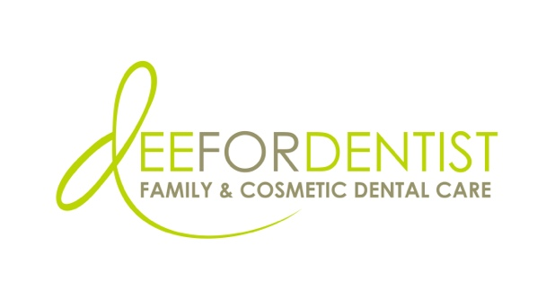

For Immediate Release

Dee for Dentist Announces the Addition of Dr. Nathan Chu, and Extended Practice Hours

Practice now open six days a week, offering Friday and Saturday appointments

September 14, 2022 – Las Vegas – Dee for Dentist, a state-of-the-art dental practice embracing groundbreaking technological innovations and techniques to treat and manage oral care, announces the addition of Dr. Nathan Chu, as well as the expansion of office hours to six days per week.

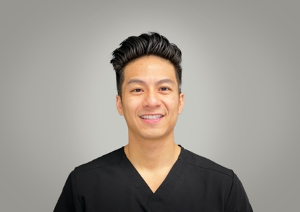
Originally from Houston, TX, Dr. Chu attended the University of Houston where earned a Bachelor of Science in Biology before relocating to Mesa, Arizona where he earned a certificate of Public Health and his Doctor of Dental Medicine at A.T. Still University’s Arizona School of Dentistry & Oral Health (ATSU-ASDOH). Passionate about giving back to the community, Dr. Chu is experienced in digital dentistry and comprehensive care including restorative procedures, oral surgery, extractions, fixed prosthodontics, endodontics, clear aligners, and implants.
Dr. Chu

Due to recent team growth and an influx of patient appointment requests, Dee for Dentist recently expanded its practice hours to conveniently offer appointments on Fridays and Saturdays from 9 a.m. to 5:30 p.m.

“We are thrilled to have Dr. Chu join our team and bring his expertise to our practice. He shares our vision of continuing education and adopting new technologies in order to provide the most advanced care possible for our patients,” said Dr. Dee Dee Meevasin, owner and primary clinician at Dee for Dentist. “And due to our growing team, we’re now able to offer patients Friday and Saturday appointments as a convenient option for those who are unable to make it during busy weekdays.”

Founded in 2011, Dee for Dentist is a family practice providing the latest in digital dentistry along with traditional dental services as a means to promote the long-term oral health of every patient. Open Monday through Saturday from 9 a.m. to 5:30 p.m., Dee for Dentist is located at 8772 South Maryland Pkwy, Las Vegas, NV 89123. For more information, visit www.deefordentist.com.

About Dee for Dentist:
An industry leader, Dee for Dentist is a local family practice providing state-of-the-art digital dentistry to the Southern Nevada community. Dr. Dee Dee Meevasin, a Las Vegas native and a graduate of the UNLV School of Dental Medicine with over two decades of industry experience, started the practice in 2011 and embraces technology along with traditional dental services as a means to promote the long-term oral health of every patient.

As the first in Las Vegas to use many of the groundbreaking innovations and techniques developed for the dental industry to treat and manage oral care, the practice offers the most advanced treatments available, including: laser dentistry, myofunctional therapy appliances for children, digital nitrous, oral sleep appliances, oral cancer detection, 3D printing, CEREC same-day crown restorations, and 3D screening for advanced airway analysis to address sleep apnea and other oral health related issues.

Dee for Dentist is a clinical partner for TeamSmile, a national organization that partners dental practices with professional athletic organizations to provide life-changing dental care to underserved children in local communities.

Dee for Dentist is open Monday through Saturday from 9 a.m. to 5:30 p.m. For more information, visit www.deefordentist.com or follow @deefordentist on Facebook and Instagram. Appointments can be requested online or made by calling (702) 586-7800.

Media Contact:
Mallory Zito
GYC Vegas
(702) 560-6590
mallory@gycvegas.com

