**For Immediate Release**

**Dee for Dentist Announces Partnership with Clark County School District for**

**District-Wide Design & Story Contest for Elementary School Students**

*Contest kicks off dental practice’s 2023 Fills Good Program; practice pledges to donate to various local organizations three times a year*

[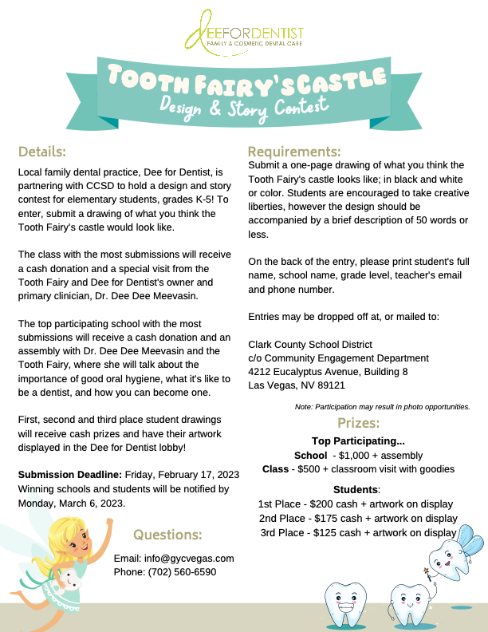](https://gycvegas.box.com/s/kot3henanz8vb9pc1tzv1bk3s2h1xi76)

*Dee for Dentist’s tooth fairy’s castle design and story contest flyer.*

**January 19, 2023 – Las Vegas** – [Dee for Dentist](https://deefordentist.com/), a state-of-the-art dental practice embracing groundbreaking technological innovations and techniques to treat and manage oral care, has partnered with the Clark County School District (CCSD) to host a district-wide design and story contest for elementary students, grades K-5, launching the practice’s 2023 [Fills Good program](https://deefordentist.com/about/fills-good/) – a community-based initiative to support local nonprofit organizations.

To enter, students are invited to submit a one-page drawing – in black and white, or color – of what they think the Tooth Fairy’s castle looks like, accompanied by a brief description of 50 words or less. To easily identify the artist, all entries must include the student's full name, school name, grade level, teacher's email and phone number on the back of their submission. Winning students and the top participating school will receive various prizes, including cash, a special presentation with Dee for Dentist’s primary clinician Dr. Dee Dee Meevasin and the Tooth Fairy, and a chance for their artwork to be displayed at the practice.

Submissions may be dropped off at, or mailed to, the Clark County School District (c/o Community Engagement Department) at 4212 Eucalyptus Avenue, Building 8, Las Vegas, NV 89121. Deadline for submissions is Friday, February 17, 2023. Winning schools and students will be chosen and notified by Monday, March 6, 2023.

“From day one, giving back to the Southern Nevada community has been one of our practice’s principal values,” said Dr. Dee Dee Meevasin, owner and primary clinician at Dee for Dentist. “By partnering with CCSD to kick off our 2023 Fills Good Program, not only are we supporting our children’s education, but we are encouraging them to be creative and think about their teeth and what the Tooth Fairy does with them.”

*Since launching the Fills Good program in 2014, Dee for Dentist has donated over $60,000 to over 30 organizations, including the Pharar Foundation.*

Since launching the Fills Good program in 2014, Dee for Dentist has donated over $60,000 to more than 30 501(c)3 organizations that serve Southern Nevada residents. Previous recipients include the annual 98.5 KLUC Chet Buchanan Show Toy Drive, the Pharar Foundation, Teens Helping Teens, Mayte’s Rescue, and more.

Founded in 2011, Dee for Dentist is a family practice providing the latest in digital dentistry along with traditional dental services as a means to promote the long-term oral health of every patient. Open Monday through Saturday from 9 a.m. to 5:30 p.m., Dee for Dentist is located at 8772 South Maryland Pkwy, Las Vegas, NV 89123. For more information, visit [www.deefordentist.com](https://deefordentist.com/).

**About Dee for Dentist:**

An industry leader, Dee for Dentist is a local family practice providing state-of-the-art digital dentistry to the Southern Nevada community. Dr. Dee Dee Meevasin, a Las Vegas native and a graduate of the UNLV School of Dental Medicine with over two decades of industry experience, started the practice in 2011 and embraces technology along with traditional dental services as a means to promote the long-term oral health of every patient.

As the first in Las Vegas to use many of the groundbreaking innovations and techniques developed for the dental industry to treat and manage oral care, the practice offers the most advanced treatments available, including: laser dentistry, myofunctional therapy appliancesfor children, digital nitrous, oral sleep appliances, oral cancer detection, 3D printing, CEREC same-day crown restorations, and 3D screening for advanced airway analysis to address sleep apnea and other oral health related issues.

Dee for Dentist is a clinical partner for TeamSmile, a national organization that partners dental practices with professional athletic organizations to provide life-changing dental care to underserved children in local communities.

Dee for Dentist is open Monday through Saturday from 9 a.m. to 5:30 p.m. For more information, visit [www.deefordentist.com](https://deefordentist.com/) or follow @deefordentist on [Facebook](https://www.facebook.com/deefordentist) and [Instagram](https://www.instagram.com/deefordentist/). Appointments can be requested online or made by calling (702) 586-7800.

**# # #**

**Media Contact:**

Mallory Zito/Briana Philippi

GYC Vegas

(702) 560-6590

[mallory@gycvegas.com](mailto:mallory@gycvegas.com)

[briana@gycvegas.com](mailto:briana@gycvegas.com)

|  |
| --- |
|  |