**For Immediate Release**

**Dee for Dentist to Host Social Media Contest Benefitting Three Local Animal Organizations**

*Contest kicks off dental practice’s Spring 2023 Fills Good initiative; Street Dogz,*

*Heaven Can Wait Animal Society, and Vegas Roots Rescue to participate*

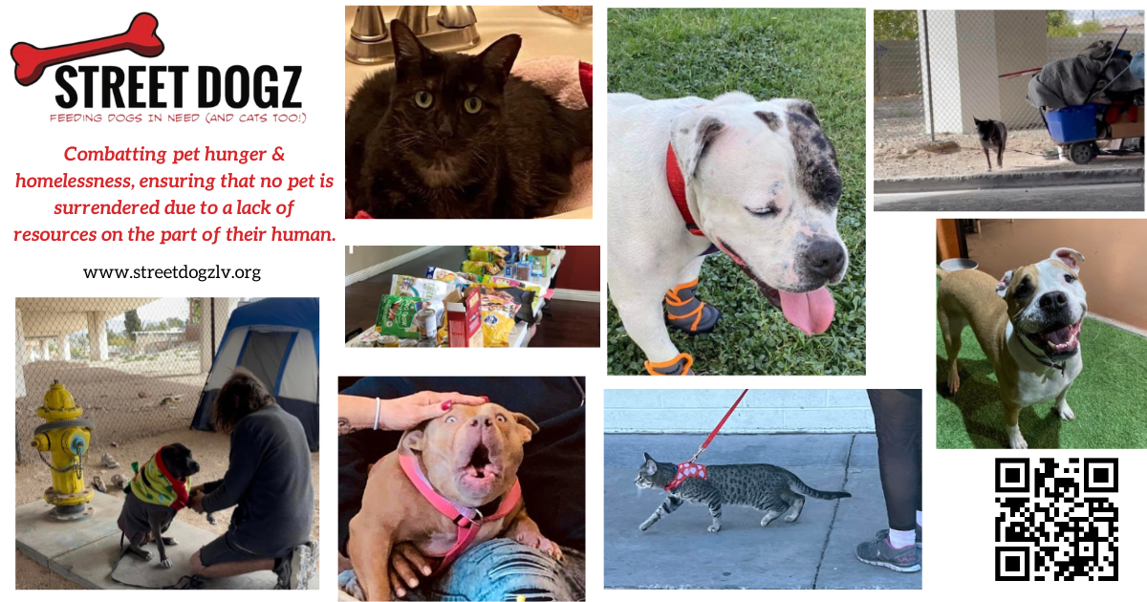

*Street Dogz is one of three organizations participating in Dee for Dentist’s Fills Good social media contest this March.*

**February 24, 2023 – Las Vegas** – [Dee for Dentist](https://deefordentist.com/), a state-of-the-art dental practice embracing groundbreaking technological innovations and techniques to treat and manage oral care, is kicking off its Spring 2023 [Fills Good program](https://deefordentist.com/about/fills-good/), a community-based initiative to support local nonprofit organizations, with a social media contest for select organizations.

With a mission to support and increase awareness of local nonprofit organizations in the community, Dee for Dentist’s Spring 2023 Fills Good program beginning in March will focus on three local animal organizations: [Street Dogz](https://streetdogzlv.org/), [Heaven Can Wait Animal Society](https://heavencanwaitlv.org/), and [Vegas Roots Rescue](https://www.vegasrootsrescue.com/).

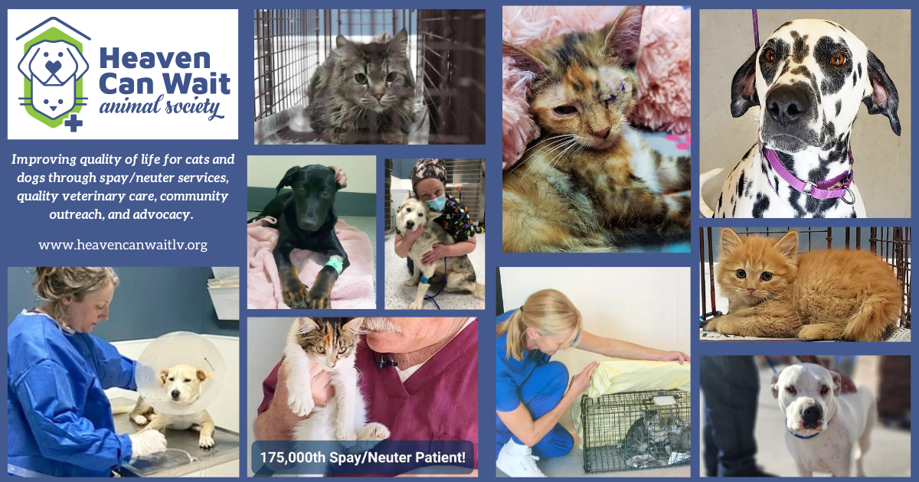

*Heaven Can Wait Animal Society is one of three organizations participating in Dee for Dentist’s Fills Good social media contest this March.*

“While we are passionate about helping our patients with their oral wellness, our second mission is supporting organizations through donations and awareness,” said Dr. Dee Dee Meevasin, owner and primary clinician at Dee for Dentist. “With so many meaningful nonprofits in town, we look forward to supporting new causes every year and shining a light on the impactful work they do.”

From March 1-17, [Street Dogz](https://streetdogzlv.org/), [Heaven Can Wait Animal Society](https://heavencanwaitlv.org/), and [Vegas Roots Rescue](https://www.vegasrootsrescue.com/) will each be featured on Dee for Dentist’s Facebook and Instagram accounts. The three organizations will have dedicated posts and will strive to receive as many likes, comments and shares as they can by March 17. The organization’s post with the most likes, comments and shares by the end of the voting period will receive a monetary prize as well as a “day of service.”

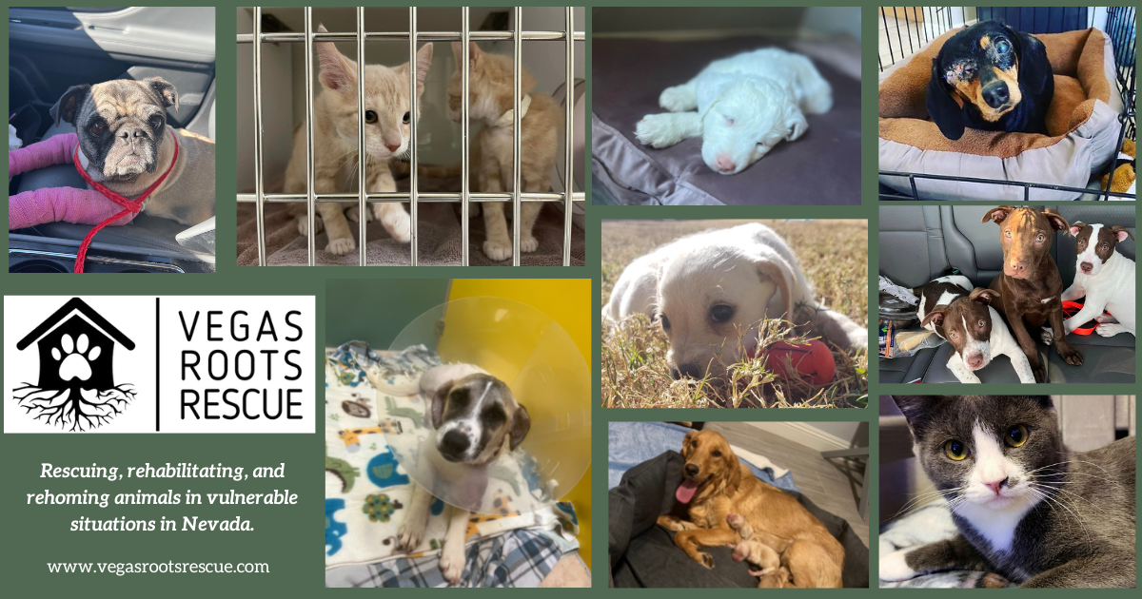

*Vegas Roots Rescue is one of three organizations participating in Dee for Dentist’s Fills Good social media contest this March.*

Open to the public, the day of service will be held Thursday, May 18, 2023 at Dee for Dentist’s Silverado Ranch location. For this day only, Dee for Dentist will donate 5% of proceeds for all restorative services to the winning organization. Those interested in scheduling an appointment on this day will need to visit Dee for Dentist for an exam or consultation prior to the day of service.

Since launching the Fills Good program in 2014, Dee for Dentist has donated over $60,000 to over 30 organizations. Previous recipients include the annual 98.5 KLUC Chet Buchanan Show Toy Drive, the Pharar Foundation, Teens Helping Teens, Mayte’s Rescue, and more.

Founded in 2011, Dee for Dentist is a family practice providing the latest in digital dentistry along with traditional dental services as a means to promote the long-term oral health of every patient. Open Monday through Saturday from 9 a.m. to 5:30 p.m., Dee for Dentist is located at 8772 South Maryland Pkwy, Las Vegas, NV 89123. For more information, visit [www.deefordentist.com](https://deefordentist.com/).

**About Dee for Dentist:**

An industry leader, Dee for Dentist is a local family practice providing state-of-the-art digital dentistry to the Southern Nevada community. Dr. Dee Dee Meevasin, a Las Vegas native and a graduate of the UNLV School of Dental Medicine with over two decades of industry experience, started the practice in 2011 and embraces technology along with traditional dental services as a means to promote the long-term oral health of every patient.

As the first in Las Vegas to use many of the groundbreaking innovations and techniques developed for the dental industry to treat and manage oral care, the practice offers the most advanced treatments available, including: laser dentistry, myofunctional therapy appliancesfor children, digital nitrous, oral sleep appliances, oral cancer detection, 3D printing, CEREC same-day crown restorations, and 3D screening for advanced airway analysis to address sleep apnea and other oral health related issues.

Dee for Dentist is a clinical partner for TeamSmile, a national organization that partners dental practices with professional athletic organizations to provide life-changing dental care to underserved children in local communities.

Dee for Dentist is open Monday through Saturday from 9 a.m. to 5:30 p.m. For more information, visit [www.deefordentist.com](https://deefordentist.com/) or follow @deefordentist on [Facebook](https://www.facebook.com/deefordentist) and [Instagram](https://www.instagram.com/deefordentist/). Appointments can be requested online or made by calling (702) 586-7800.

**Media Contact:**

Mallory Zito / Briana Philippi

GYC Vegas

(702) 560-6590

[mallory@gycvegas.com](mailto:mallory@gycvegas.com) / [briana@gycvegas.com](mailto:briana@gycvegas.com)

|  |
| --- |
|  |