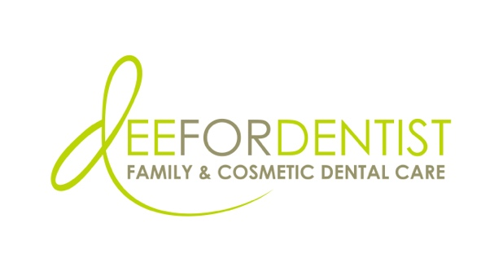

For Immediate Release

Dee for Dentist Expands with the Acquisition of Las Vegas Dentistry

Second location allows more Southern Nevadans to benefit from the practice’s unique,
state-of-the-art digital dentistry services

March 27, 2023 – Las Vegas – Dee for Dentist, a state-of-the-art dental practice embracing groundbreaking technological innovations and techniques to treat and manage oral care, has acquired Las Vegas Dentistry located at 2421 West Charleston Blvd., Las Vegas, NV 89102, marking the second brick-and-mortar practice owned by Dr. Dee Dee Meevasin.
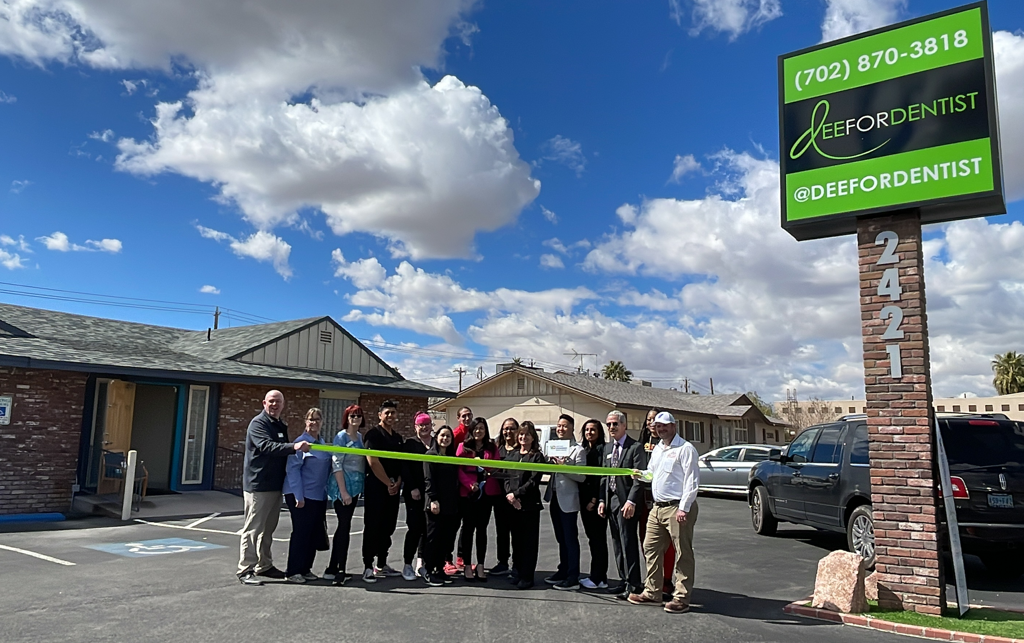
The opening of Dee for Dentist’s Medical District location was commemorated with a ribbon-cutting ceremony officiated by the Vegas Chamber and the Henderson Chamber of Commerce.

“With our original practice located in the Silverado Ranch area of Las Vegas, we are excited to acquire a second office that is centrally located to better serve patients across the valley,” said Dr. Dee Dee Meevasin, owner and primary clinician at Dee for Dentist. “Patients can expect the same level of advanced technology and elevated patient care that we are recognized for throughout Southern Nevada.”

The former Las Vegas Dentistry practice features 2,800 square feet of space and six patient rooms. Dee for Dentist is expanding treatment options at this location to include its signature line of cutting-edge dental technology services such as the Solea Laser for anesthesia-free cavity fillings and snoring therapy, digitally guided dental implantology, and 3D printed appliances. The practice has two dentists and a dental hygienist on staff and is open Monday-Thursday from 8 a.m. to 5 p.m.

“Having personally known Dr. Meevasin and her team for many years, I could not be more excited to join the Dee for Dentist family,” said Dr. Dhesi, primary clinician at Las Vegas Dentistry. “Dr. Meevasin and her team bring with them the latest dental technology which provides patients the most advanced treatment options available in the dental industry.”
As the first and often only in Las Vegas to use many of the groundbreaking innovations and techniques developed for the dental industry to treat and manage oral health, Dee for Dentist offers the most progressive treatments available, including: laser dentistry for anesthesia-free cavity fillings, myofunctional therapy appliances for children, digital nitrous, oral sleep appliances, oral cancer detection, 3D printing, CEREC same-day crown restorations, and 3D screening for advanced airway analysis to address sleep apnea and other oral health related issues. Earlier this year they were the first dental practice in the Western U.S. to utilize the first-ever medical grade 3D printer for dentistry – the Primeprint 3D Printing System by Dentsply Sirona.
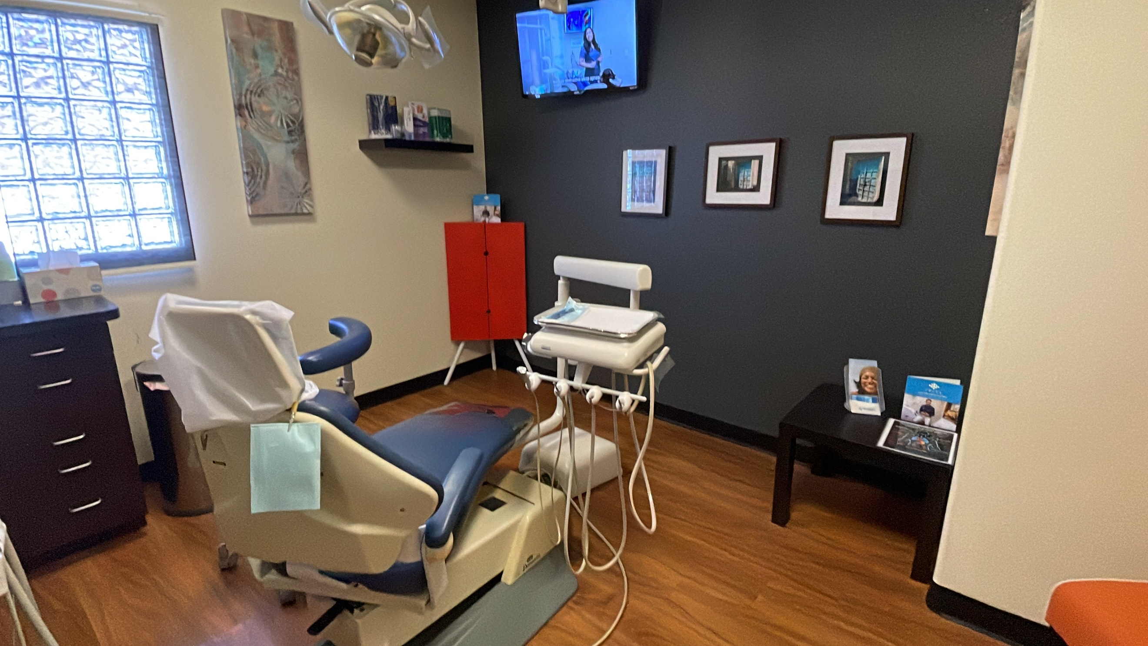
The former Las Vegas Dentistry practice features 2,800 square feet of space and six patient rooms, and includes Dee for Dentist’s state-of-the-art digital dentistry treatment options.

Dee for Dentist’s Silverado Ranch practice is located at 8772 South Maryland Pkwy, Las Vegas, NV 89123. For more information, visit www.deefordentist.com.

About Dee for Dentist:
An industry leader, Dee for Dentist is a local family practice providing state-of-the-art digital dentistry to the Southern Nevada community. Dr. Dee Dee Meevasin, a Las Vegas native and a graduate of the UNLV School of Dental Medicine with over two decades of industry experience, started the practice in 2011 and embraces technology along with traditional dental services as a means to promote the long-term oral health of every patient.

As the first in Las Vegas to use many of the groundbreaking innovations and techniques developed for the dental industry to treat and manage oral care, the practice offers the most advanced treatments available, including: laser dentistry, myofunctional therapy appliances for children, digital nitrous, oral sleep appliances, oral cancer detection, 3D printing, CEREC same-day crown restorations, and 3D screening for advanced airway analysis to address sleep apnea and other oral health related issues.

Dee for Dentist is a clinical partner for TeamSmile, a national organization that partners dental practices with professional athletic organizations to provide life-changing dental care to underserved children in local communities.

Dee for Dentist’s Silverado Ranch practice is open Monday through Saturday from 9 a.m. to 5:30 p.m. and their Charleston practice is open Monday through Thursday from 8 a.m. to 5 p.m. For more information, visit www.deefordentist.com or follow @deefordentist on Facebook and Instagram. Appointments can be requested online or made by calling (702) 586-7800.

Media Contact:
Mallory Zito
GYC Vegas
(702) 560-6590
mallory@gycvegas.com

